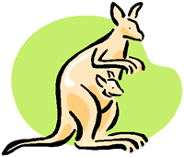
Кенгуренку Кенгуру
Говорила поутру:
"Надо быстренько вставать
И английский повторять":
To write - wrote - written,
To eat - ate - eaten,
To speak - spoke - spoken,
To break - broke - broken.
To come - came - come,
To become - became - become,
To run - ran - run,
To swim - swam - swum.
To know - knew - known,
To throw - threw - thrown,
To blow - blew - blown,
To fly - flew - flown.
To sing - sang - sung,
To ring - rang - rung,
To hide - hid - hidden,
To bite - bit - bitten.
To send - sent - sent,
To spend - spent - spent,
To sleep - slept - slept,
To keep - kept - kept.
To tell - told - told,
To sell - sold - sold,
To teach - taught - taught,
To catch - caught - caught.
To fight - fought - fought,
To think - thought - thought,
To buy - bought - bought,
To bring - brought - brought.
To cut - cut - cut,
To shut - shut - shut,
To cost - cost - cost,
To lose - lost - lost.
To lead - led - led,
To feed - fed - fed,
To feel - felt - felt,
To hold - held - held.

