Grammar
1. Complete the sentences with am, is, are.
- 1) There … pears in the basket.
2) He … not a teacher. He works in the shop.
3) It’s raining in the street. I … all wet.
4) There … not any chocolate in the fridge.
5) … they Americans? – No, but their mother is American.
2. Answer the questions.
- 1) What season is the coldest? –
2) What season is it now? –
3) What’s your favorite food? –
4) Why do people wear light clothes in summer? –
5) When do you have dinner with your family? –

3. Choose the correct variant.
- 1) Listen! The bird … in the tree. (sings/is singing)
2) I usually … books in the evening. (read/am reading)
3) David … to work; he is a pupil. (doesn’t go; isn’t working)
4) They … in the yard at the moment. (play; are playing)
5) … you often … trousers? (Do ... wear; Are … wearing)

4. Complete the sentences with some, any.
- 1) There is … milk in the bottle.
2) Are there … oranges in the bag?
3) There isn’t … porridge in the plate.
4) There are … carrots on the table.
5) Is there … water at the front door?
Reading
5. Agree or disagree.
 | I agree | I disagree
0) Sandra is a girl. | +
1) Jack lives in a flat.
2) Sandra’s grandmother is good at painting.
3) Sandra is older than her cousin.
4) Jack’s parents are engineers.
5) Sandra’s aunt is her mother’s sister.
Hi, my name is Sandra. I am twelve years old and I live in New York, in a small house. I have an amazing family which I love very much. There are seven members in my family. They are my grandparents, my mother, my aunt and uncle, me and my cousin. My grandfather is a vet who takes care of different pets and animals. My grandmother is a talented artist and a kind person. My mother is a lawyer and a great cook. My aunt and uncle are engineers who work together on big projects. My cousin, Jack, is fifteen years old and he wants to become an artist. I love my family very much and we all get along very well.
6. Fill in the words from the table.
autumn | winter | ice cream | ski | flowers
spring | summer | rains | swim | move
icy | colours | snowman | colder | birds
In … school finishes and holidays begin. People go to the beach to … and sunbathe. Children like to eat … in hot weather.
In … snow melts. … start to grow – snowdrops, roses, tulips, violets. They are of different … : white, red, yellow, pink. Some … come back from warmer countries.
In … days get shorter and nights get … . It often … a lot. Leaves fall from the trees and birds … to other countries.
In … lakes and rivers are frozen and roads are … and slippery. Children go outside to make a … with a carrot for a nose. People like to … in the hills and mountains.
Vocabulary
7. Write the things.
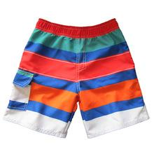 | 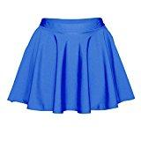 | 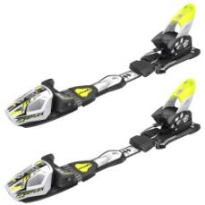 | 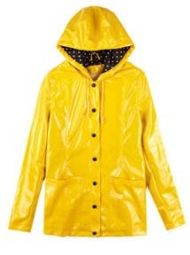 | 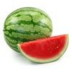 | 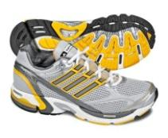
0 shorts | 1 | 2 | 3 | 4 | 5

Writing
9. Complete the dialogue. Use the words you know.
AGood ……………………………….., David! How are ……………………?
B Morning, Carol! I’m fine. And …………………………….?
A I’m ………………………….., too. Thank ………………………..
B The weather is not rainy, it’s …………………………. today. Let’s have a picnic!
A With pleasure! I’ll bring some ……………………………… and jam.
B And I’ll bring ………………………………. juice and sausage.
A Wonderful! Let’s meet ……………………………….. 1:15 p.m.
B OK. Good-………………………….!
A See you later!

